**BitShow**

Create a website whose main purpose is to provide information to the users about TV shows.

**Requirements**

* Landing Page
  + Top 50 TV shows should be presented on this page
  + When the user clicks on the show, he’s redirected to the “Show Info Page”
  + The user can use search box on the page to search for shows
  + Searching is done on all available shows (TvMaze API), not just on the local list
  + When presenting the result in search dropdown list, don’t list more than 10 shows
* Show Info Page
  + The page should contain TV show name, show poster and description
  + Provide number of seasons as well as the start and end date of each season
  + Provide the cast list
* Extra features
  + Show crew
  + Show AKA’s
  + Show episode list
  + Responsive design

**Building tools**

Bootstrap 4

SASS

**API**

Documentation: [http://api.tvmaze.com](http://api.tvmaze.com/)

List of shows endpoint: <http://api.tvmaze.com/shows>

Single show data: <http://api.tvmaze.com/shows/><show_id>

**Landing Page**

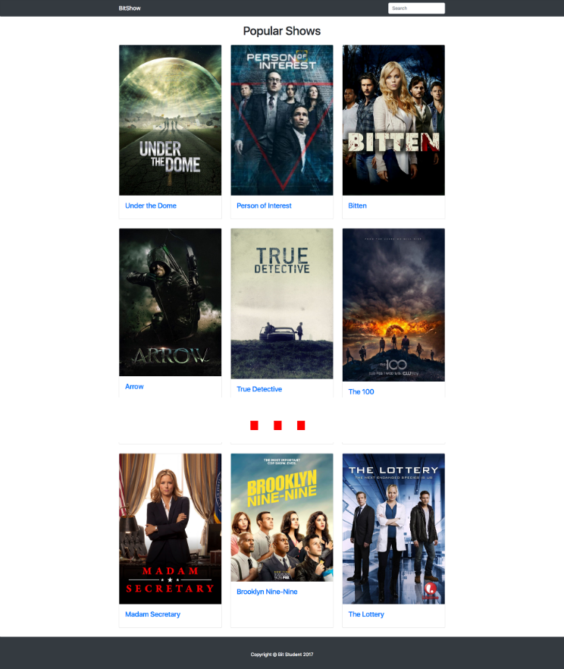

**Searching for Shows (Landing Page)**

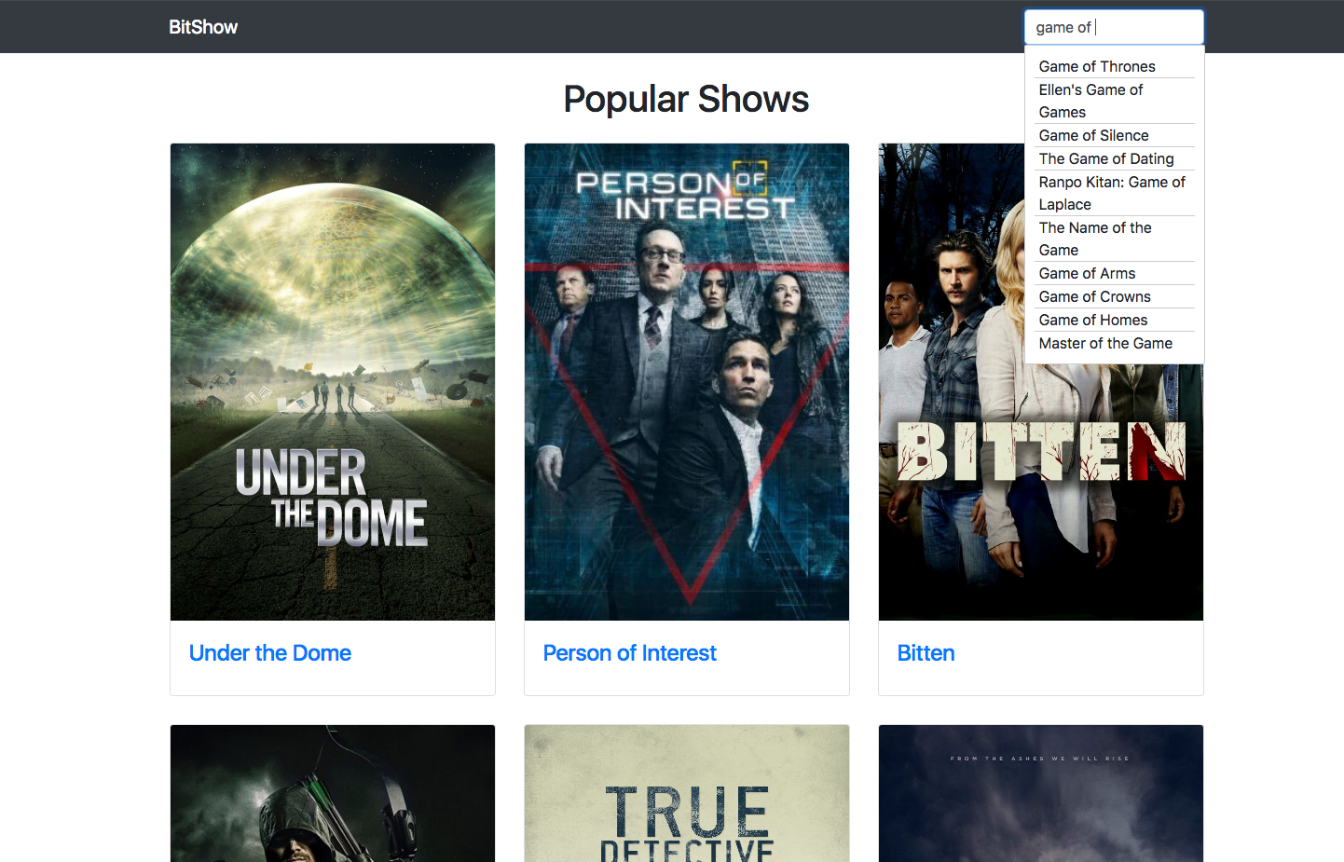

**Show Info Page**

